Test Case: tc003_SPX_Dev5_Crear_Requisicion_Spot_Tipo_Cobro_CC_Urgent
Step 1 - Enter username and password and click to button Enter : Credentials Entered
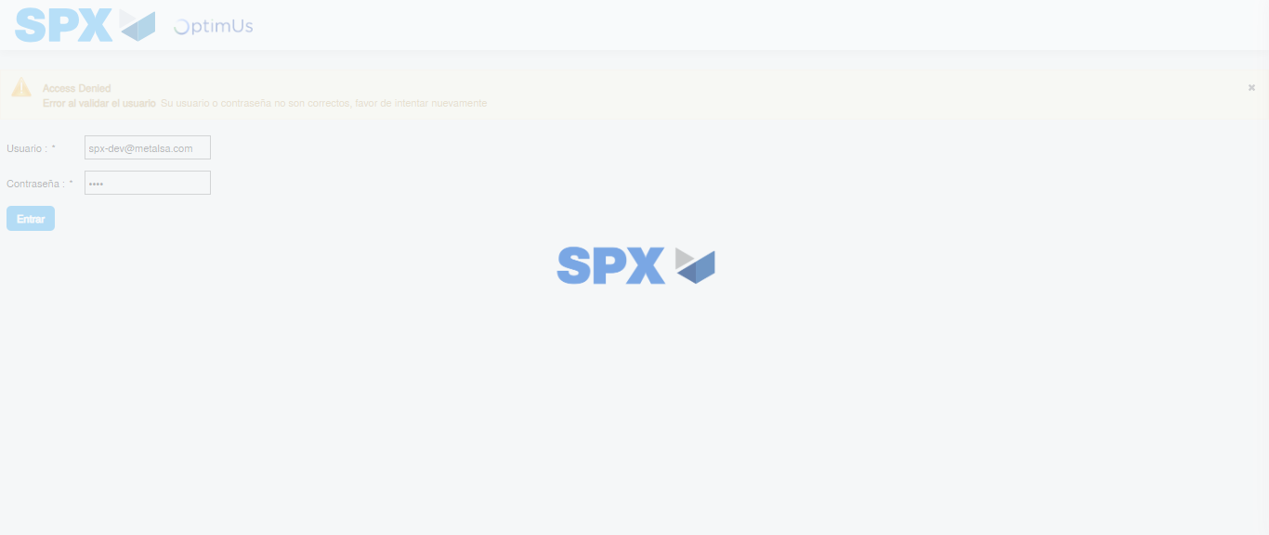Image file-name: QC_Testing-tc003_SPX_Dev5_Crear_Requisicion_Spot_Tipo_Cobro_CC_Urgent-1782315151678

Step 2 - Select to UEN and Access to Spot Buy Requisitions : UEN Correctly selected and Correct access
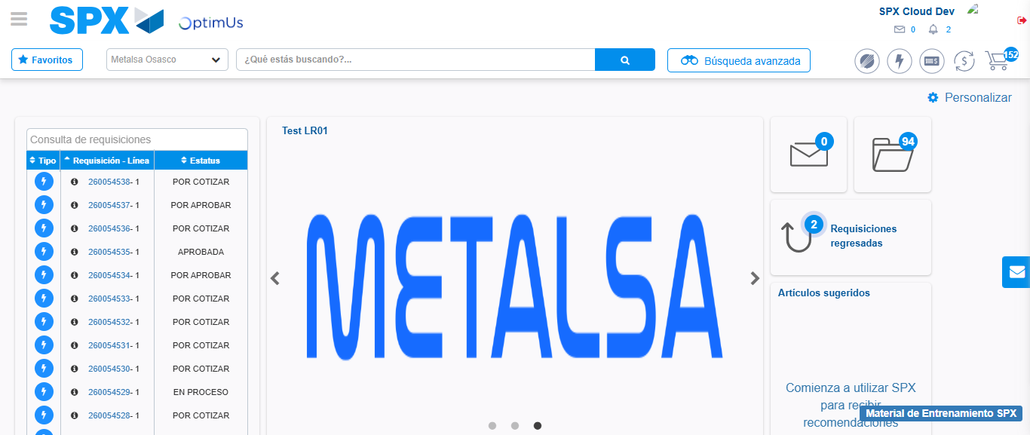Image file-name: QC_Testing-tc003_SPX_Dev5_Crear_Requisicion_Spot_Tipo_Cobro_CC_Urgent-1782315230378

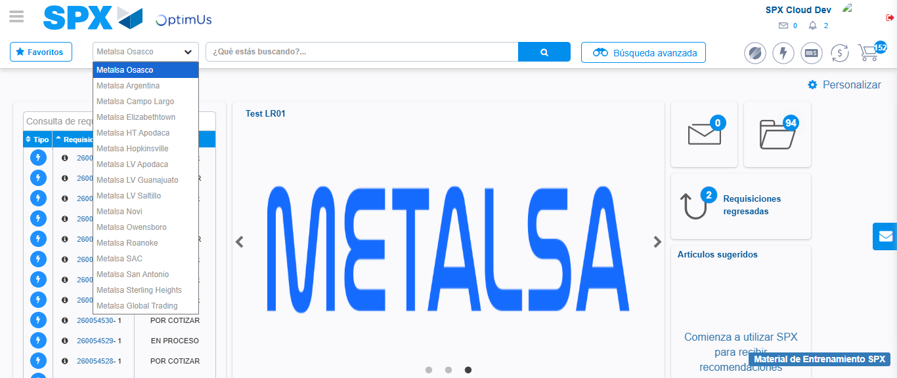Image file-name: QC_Testing-tc003_SPX_Dev5_Crear_Requisicion_Spot_Tipo_Cobro_CC_Urgent-1782315233242

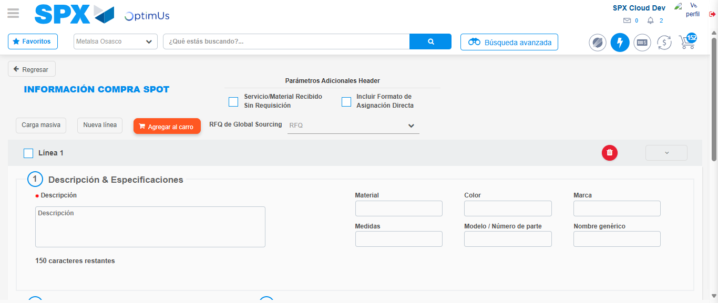Image file-name: QC_Testing-tc003_SPX_Dev5_Crear_Requisicion_Spot_Tipo_Cobro_CC_Urgent-1782315242784

Step 3 - Data Capture Spot Buy Requisition: Data captured correctly
Image file-name: QC_Testing-tc003_SPX_Dev5_Crear_Requisicion_Spot_Tipo_Cobro_CC_Urgent-1782315243116

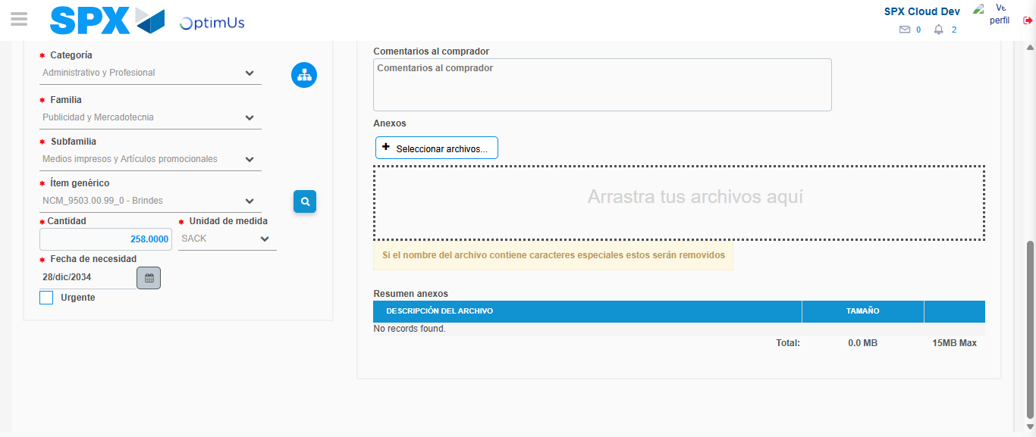Image file-name: QC_Testing-tc003_SPX_Dev5_Crear_Requisicion_Spot_Tipo_Cobro_CC_Urgent-1782315257981

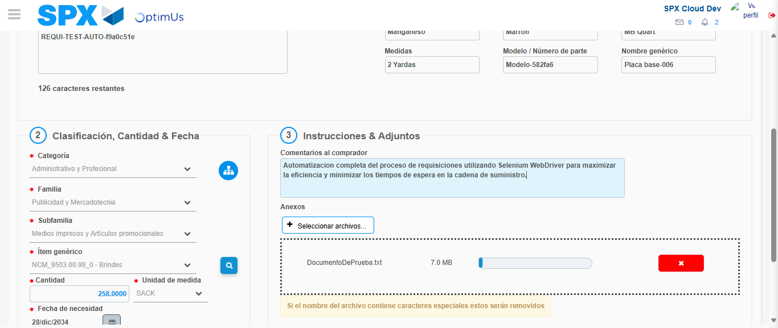Image file-name: QC_Testing-tc003_SPX_Dev5_Crear_Requisicion_Spot_Tipo_Cobro_CC_Urgent-1782315258978

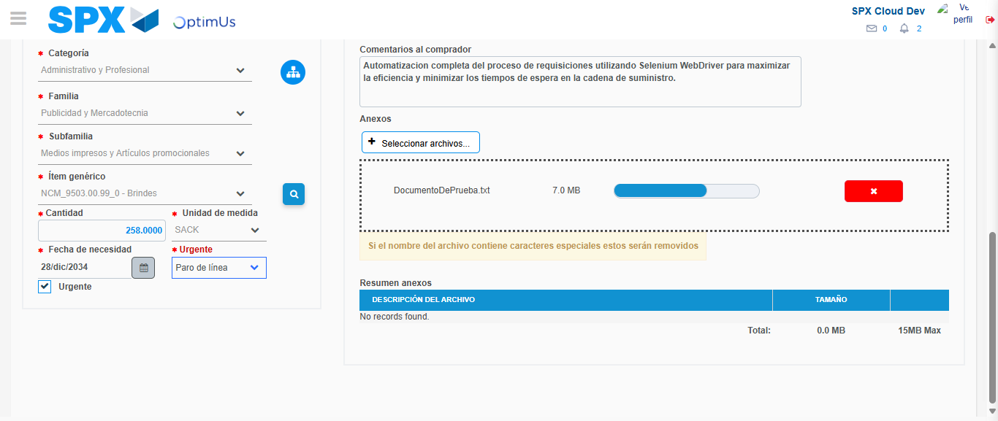Image file-name: QC_Testing-tc003_SPX_Dev5_Crear_Requisicion_Spot_Tipo_Cobro_CC_Urgent-1782315262974

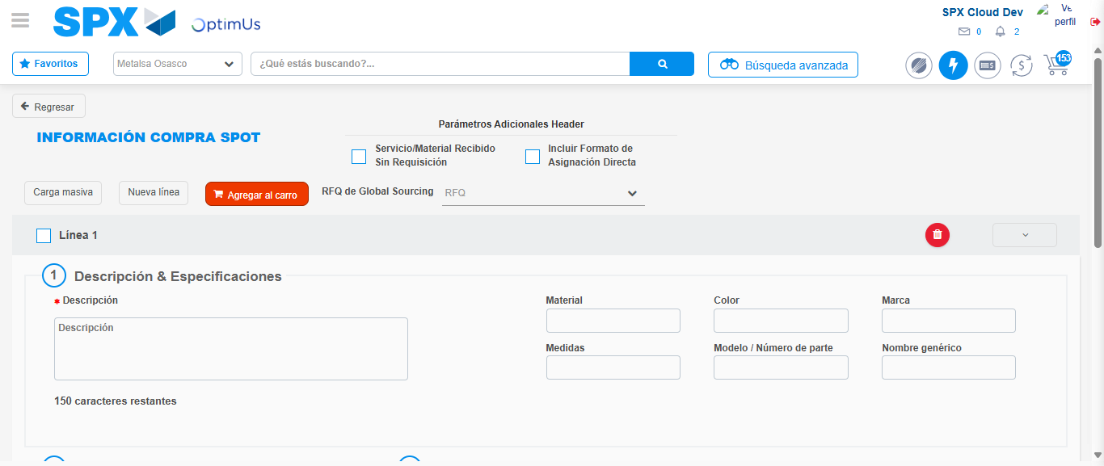Image file-name: QC_Testing-tc003_SPX_Dev5_Crear_Requisicion_Spot_Tipo_Cobro_CC_Urgent-1782315284242

Step 7 - Return to Main Page SPX : Return to Main Page SPX
Image file-name: QC_Testing-tc003_SPX_Dev5_Crear_Requisicion_Spot_Tipo_Cobro_CC_Urgent-1782315230378

Image file-name: QC_Testing-tc003_SPX_Dev5_Crear_Requisicion_Spot_Tipo_Cobro_CC_Urgent-1782315233242

Image file-name: QC_Testing-tc003_SPX_Dev5_Crear_Requisicion_Spot_Tipo_Cobro_CC_Urgent-1782315242784

Image file-name: QC_Testing-tc003_SPX_Dev5_Crear_Requisicion_Spot_Tipo_Cobro_CC_Urgent-1782315286600

Image file-name: QC_Testing-tc003_SPX_Dev5_Crear_Requisicion_Spot_Tipo_Cobro_CC_Urgent-1782315286862

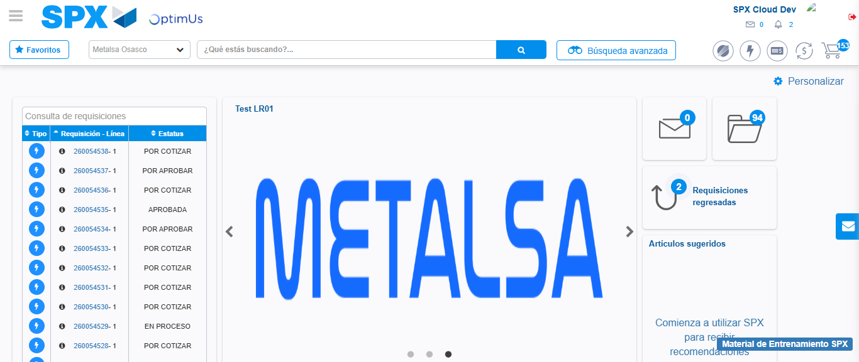Image file-name: QC_Testing-tc003_SPX_Dev5_Crear_Requisicion_Spot_Tipo_Cobro_CC_Urgent-1782315308164

Step 8 - Log Out : Log Out SPX
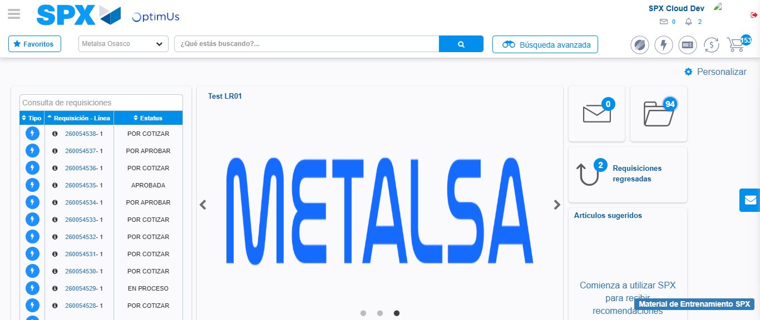Image file-name: QC_Testing-tc003_SPX_Dev5_Crear_Requisicion_Spot_Tipo_Cobro_CC_Urgent-1782315308513

